Community | Serve
Carson: Wed 7:00 PM  Central Torrance: Thu 6:30pm  West-Central Torrance: Wed 6:30 PM  Palos Verdes: Thurs 7:00 PM  OC: Wed 7:00 PM  West LA: Tues 6:30 PM  DTLA: Wed 6:30 PM  Sunday*: Sun 2:00 PM  *Sunday community group is reserved for people who can’t attend a weeknight group.    Scan the QR code to sign up! To learn more, talk to Pastor Esther Yi or visit our website at southbaymissionchurch.com/cg. | Please contact the ministry leader or visit southbaymissionchurch.com/serve  Admin*: Michael Huh  Fellowship: George Dai  Finance*:  Hospitality: Christine Lee  Media: Justin Ignacio  Member Care: Vanessa Lam  Missions: Eric Kawaguchi  Missions Café: Yisak Kim  Outreach: Ana Shin  Praise*: Pastor Daniel Kim  Prayer: Jessica Song  Setup: Wesley Yoo  Welcoming: Steven Lee  *For covenant Members only.

Contact
Tim Lee | Lead Pastor  (310)613-6721  pastortimlee@gmail.com  Esther Yi | Community Group Pastor  (562)544-9202  esyi1209@gmail.com | Daniel Kim | Worship Pastor  (415)385-2422  danielpotterkim@gmail.com  Esther Kim | Preschool Min. Pastor  (310)850-8626  kimesther105@gmail.com

2531 W 237th Unit 22, Torrance, CA 90505
(424)571-3020 | southbaymissionchurch.com
Announcements | November 30, 2025

- We are having communion today during service to kick off Advent, a season of reflecting on Jesus’ birth and anticipating His 2nd coming.
- We are collecting new, unwrapped toys for the Lawndale School Toy Drive until 12/14. We are accepting toys that cost around $25 as well as monetary donations. Our goal is to provide toys for 150 kids. Please sign up to donate at https://tinyurl.com/sbmctoydrive2025.
- Leaders’ Appreciation is next Sunday, 12/7 at 2pm! If you are a CG or Ministry leader, please be sure to mark your calendars. It will be held at Scott & Diane’s house.
- Covenant Members’ End-of-Year Meeting is on 12/14. We will be voting on a couple important items so please be sure to attend!
- Save the date: Women’s Christmas Fellowship (12/20), Christmas service (12/21@9am), Men’s Fellowship (1/17), Anniversary service (1/25). More details to come!
- Please read and meditate on James 5:1-6 during the week in preparation for next week’s sermon.
If you missed a sermon, visit us on Spotify at https://tinyurl.com/sbmc-sermons or on our YouTube channel.

Upcoming Events | Giving
12/11 – Fall CG ends  12/14 – LESD Toy Drive ends  12/14 – Covenant Members’ Meeting  12/20 – Women’s Christmas Fellowship  12/21 – Christmas Service  1/4 – Winter CG begins  1/17 – Men’s Fellowship  1/25 – Anniversary Service  2/1/26 – Covenant Membership Class begins  2/8 – Superbowl Party  2/18 – Lent begins  3/8 – Baptism class begins  3/15 – Leaders’ Meeting  3/22 – Covenant Members meeting | Scan QR code or add sbmissionchurch@gmail.com as a Zelle contact to make offerings and donations. *Offerings via Zelle are not anonymous.  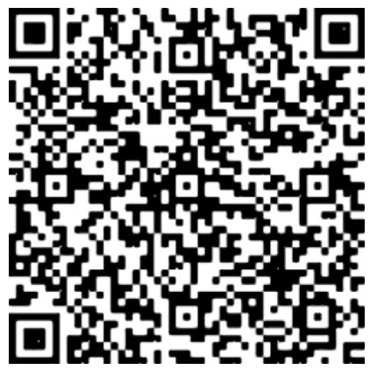

Sermon Notes | November 30, 2025

Eph 2:10 and 1 John 3:1

Guest Speaker: Pastor John Lee

Discussion Questions | November 30, 2025
Getting Started
- From the sermon or your direct reading of Eph 2:10 and 1 John 3:1, what surprised, encouraged, or challenged you?

- How is the love of God superior to all other loves?

Going Deeper
- Why is the unconditional love of God so easily taken for granted? In what ways do you think you’ve been taking God’s unconditional love for granted and why?

- How do we get transformed by God's love? In what ways has your life been changed by God’s love? Think about some ways you can reflect and meditate on God’s unconditional love this week.

