Community | Serve
Carson: Wed 7:00 PM  Central Torrance: Thu 6:30pm  West-Central Torrance: Wed 6:30 PM  Palos Verdes: Thurs 7:00 PM  OC: Wed 7:00 PM  West LA: Tues 6:30 PM  DTLA: Wed 6:30 PM  Sunday*: Sun 2:00 PM  *Sunday community group is reserved for people who can’t attend a weeknight group.  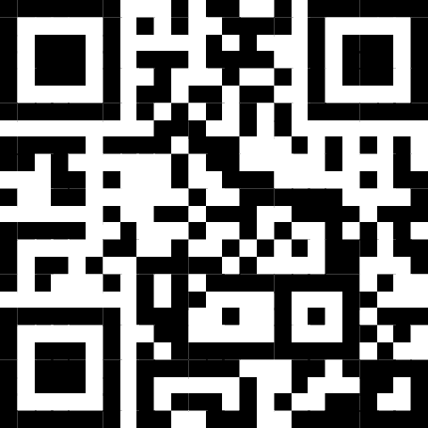  Scan the QR code to sign up! To learn more, talk to Pastor Esther Yi or visit our website at southbaymissionchurch.com/cg. | Please contact the ministry leader or visit southbaymissionchurch.com/serve  Admin*: Michael Huh  Fellowship: George Dai  Finance*:  Hospitality: Christine Lee  Media: Justin Ignacio  Member Care: Vanessa Lam  Missions: Eric Kawaguchi  Missions Café: Yisak Kim  Outreach: Ana Shin  Praise*: Pastor Daniel Kim  Prayer: Jessica Song  Setup: Wesley Yoo  Welcoming: Steven Lee  *For covenant Members only.

Contact
Tim Lee | Lead Pastor  (310)613-6721  pastortimlee@gmail.com  Esther Yi | Community Group Pastor  (562)544-9202  esyi1209@gmail.com | Daniel Kim | Worship Pastor  (415)385-2422  danielpotterkim@gmail.com  Esther Kim | Preschool Min. Pastor  (310)850-8626  kimesther105@gmail.com

2531 W 237th Unit 22, Torrance, CA 90505
(424)571-3020 | southbaymissionchurch.com
Announcements | October 26, 2025

- Trunk or Treat is today after the 11am service! Join us for games, treats, and fellowship! Treat bags will be provided for every child. If you signed up for a trunk, there will be some time after service to finish setting up so please prioritize God first.
- Baptism Class begins next Sunday, 11/2 at 9:30am. If you’d like to get baptized on Thanksgiving Sunday or learn more about baptism in general, please be sure to sign up at https://tinyurl.com/sbmc-baptism.
- Men’s Fellowship is on 11/15! Join us for a time of connection and fun! More details to follow.
- Save the date! Newcomers’ Class, (11/2), Thanksgiving Service (11/23), Advent (11/30), Leaders’ Appreciation (12/7), Women’s Christmas Fellowship (12/20), Christmas service (12/21). More details to come!
- Please read and meditate on James 3:1-12 during the week in preparation for next week’s sermon.
If you missed a sermon, visit us on Spotify at https://tinyurl.com/sbmc-sermons or our YouTube channel.

Upcoming Events | Giving
11/2 – Baptism class begins  11/2 – Newcomers’ class  11/15 – Men’s fellowship  11//23 – Thanksgiving Service  11/30 – Advent begins  December – LESD Outreach  12/14 – Covenant Members’ Meeting  12/20 – Women’s Christmas Fellowship  12/21 – Christmas Service | Scan QR code or add sbmissionchurch@gmail.com as a Zelle contact to make offerings and donations. *Offerings via Zelle are not anonymous.  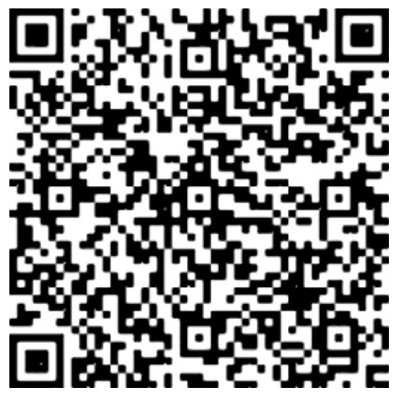

Sermon Notes | October 26, 2025

James 2:14- 26

Speaker: Pastor Tim Lee

Question: How can we have a faith that _____________?
- We need to know that faith and works cannot be __________________ (14-19).

- We need a faith that is evidenced by _________________ obedience (20-26).

Main Point: _____________________ faith is evidenced through _________________ obedience.
Discussion Questions | October 26, 2025

Getting Started
- From the sermon or your direct reading of James 2:14-26, what surprised, encouraged, or challenged you?

- Can you think of a time when your faith led you to obey even when it was difficult or uncomfortable?

Going Deeper
- What kinds of “works” flow naturally from your faith and which ones require more intentional surrender, and why?

- Think of all the different areas of your life (work/school, home, church, etc.). Where might God be calling you right now to take a step of “difficult obedience”?

