Community | Serve
Carson: Wed 7:00 PM  Central Torrance: Thu 6:30pm  West-Central Torrance: Wed 6:30 PM  Palos Verdes: Thurs 7:00 PM  OC: Wed 7:00 PM  West LA: Tues 6:30 PM  DTLA: Wed 6:30 PM  Sunday*: Sun 2:00 PM  *Sunday community group is reserved for people who can’t attend a weeknight group.    Scan the QR code to sign up! To learn more, talk to Pastor Esther Yi or visit our website at southbaymissionchurch.com/cg. | Please contact the ministry leader or visit southbaymissionchurch.com/serve  Admin*: Michael Huh  Fellowship: George Dai  Finance*:  Hospitality: Christine Lee  Media: Justin Ignacio  Member Care: Vanessa Lam  Missions: Eric Kawaguchi  Missions Café: Yisak Kim  Outreach: Ana Shin  Praise*: Pastor Daniel Kim  Prayer: Jessica Song  Setup: Wesley Yoo  Welcoming: Steven Lee  *For covenant Members only.

Contact
Tim Lee | Lead Pastor  (310)613-6721  pastortimlee@gmail.com  Esther Yi | Community Group Pastor  (562)544-9202  esyi1209@gmail.com | Daniel Kim | Worship Pastor  (415)385-2422  danielpotterkim@gmail.com  Esther Kim | Preschool Min. Pastor  (310)850-8626  kimesther105@gmail.com

2531 W 237th Unit 22, Torrance, CA 90505
(424)571-3020 | southbaymissionchurch.com
Announcements | November 2, 2025

- Newcomers class is today shortly after the 11am service. You’ll get a chance to meet other newcomers and learn more about our church.
- Men’s Fellowship is on 11/15! Join us for a time of connection and fun! More details to follow.
- Be sure to join us on 11/12 for our Thanksgiving Service! There will also be a potluck after the 11am service.
- Save the date: Advent (11/30), Leaders’ Appreciation (12/7), Women’s Christmas Fellowship (12/20), Christmas service (12/21). More details to come!
- Please read and meditate on James 3:13-18 during the week in preparation for next week’s sermon.

If you missed a sermon, visit us on Spotify at https://tinyurl.com/sbmc-sermons or our YouTube channel.

Upcoming Events | Giving
11/15 – Men’s fellowship  11//23 – Thanksgiving Service  11/30 – Advent begins  December – LESD Outreach  12/11 – Fall CG ends  12/14 – Covenant Members’ Meeting  12/20 – Women’s Christmas Fellowship  12/21 – Christmas Service  1/4 – Winter CG begins  1/25 – Anniversary Service | Scan QR code or add sbmissionchurch@gmail.com as a Zelle contact to make offerings and donations. *Offerings via Zelle are not anonymous.  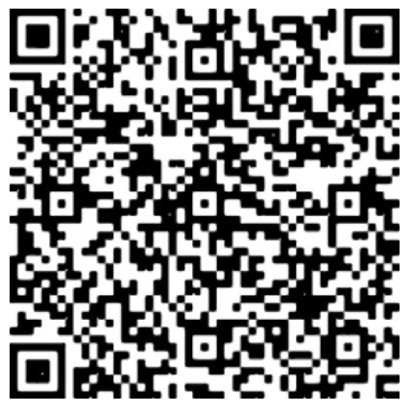

Sermon Notes | November 2, 2025

James 3:1-12

Speaker: Pastor Tim Lee

Question: Why must Christians _______________ our tongue?
- Your words can ______________ others down (vv3-6).

- Your words can give _______________ (vv9-10).

Main Point: We must allow the gospel to __________________ our hearts so that our words can be a ________________ to others.

Discussion Questions | November 2, 2025

Getting Started
- From the sermon or your direct reading of James 3:1-12, what surprised, encouraged, or challenged you?

- When have you seen or experienced a time when someone’s speech caused harm?

Going Deeper
- Reflect on a time when your speech caused harm, whether intentionally or unintentionally. What was driving your tone, choice of words, or timing? What did your words reveal about your heart in that moment?

- Consider the way you use your speech at home, work, school, church, etc. How are your words reflecting the Gospel and giving life? Do your words build up or tear down? How can you surrender the use of your tongue completely to God?

